Report of creating kali linux virtual machine and the window 10 virtual machine on VMware
Kali linux installation
Interface of VMware:
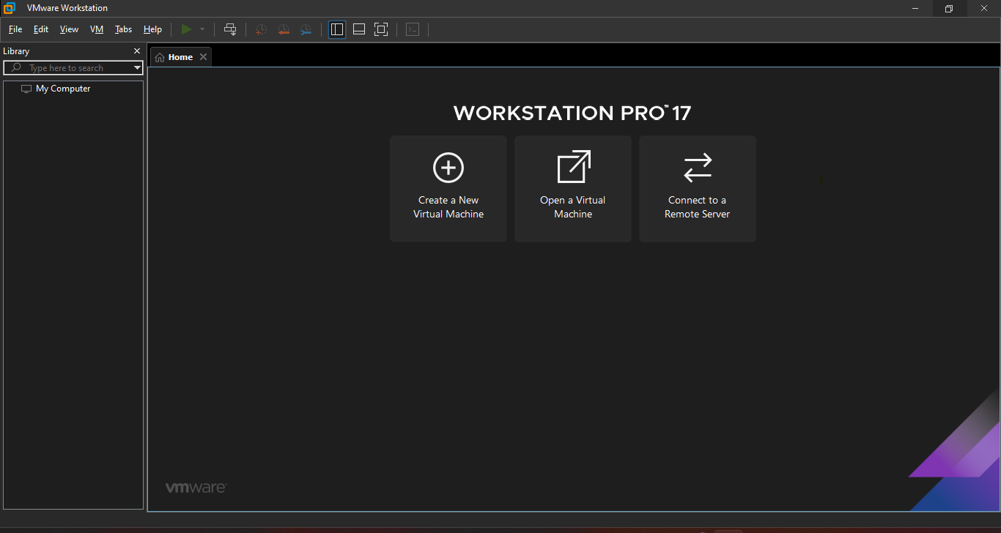
Click on create new virtual machine and then this will appear:
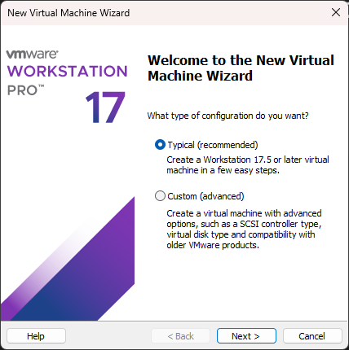
Choose the typical option and then press next
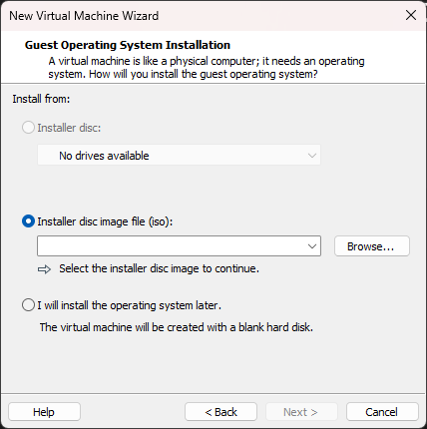
Here select the ios file that you have downloaded from chrome
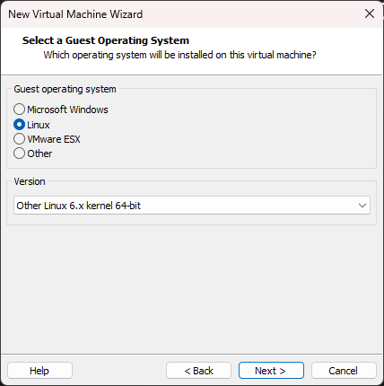
Then select the operating system and its version after that you have to give the name of the virtual machine and also select the location where you want to store the virtual machine.
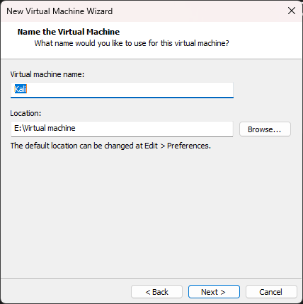
Now select the disk size and also select the store as single file for better performance:
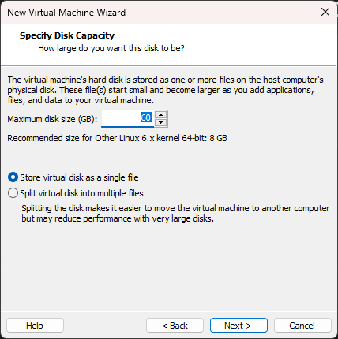
Now after clicking next you have to click on the customize hardware to change the memory and chose the host only option for network so that we can Set both Kali and Windows adapters to the same Host-only
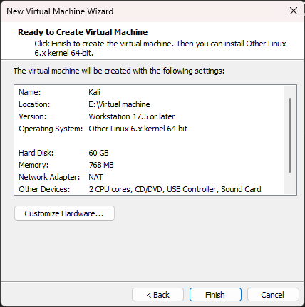
Make sure the settings are like that
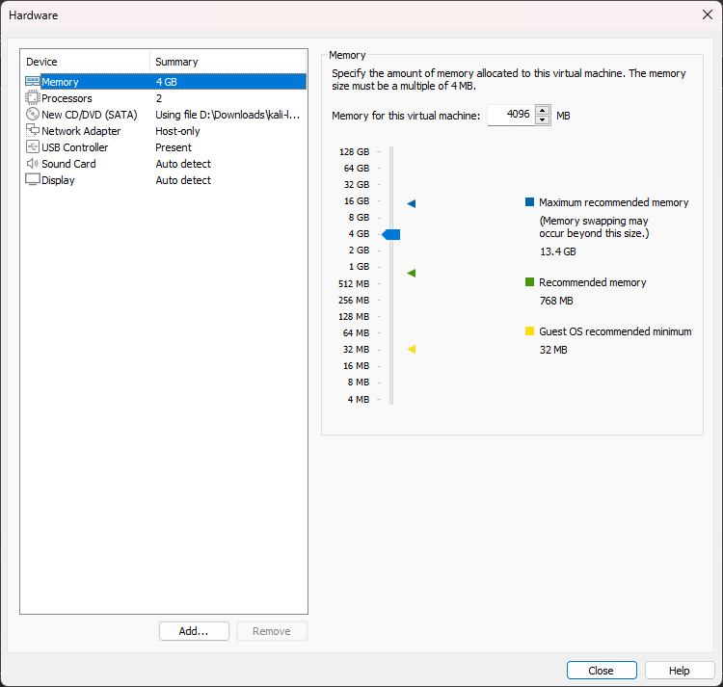
After completing the click create and then you will something like this:
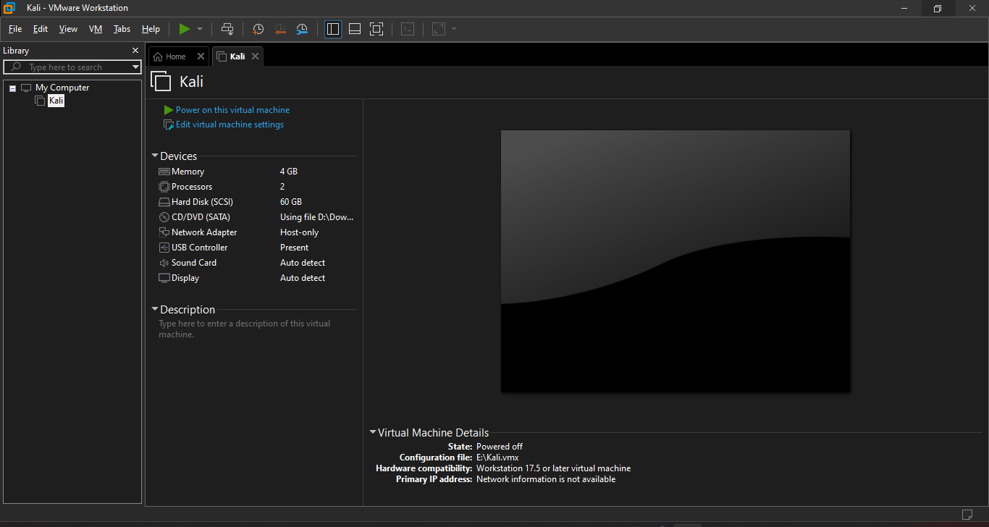
Click on the power on to start the virtual machine
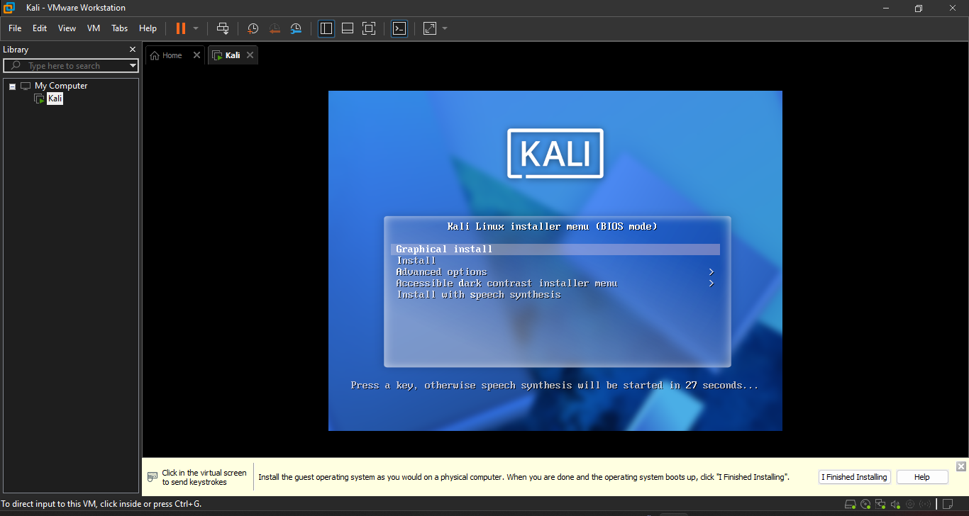
Chose the graphical install option and then select the language
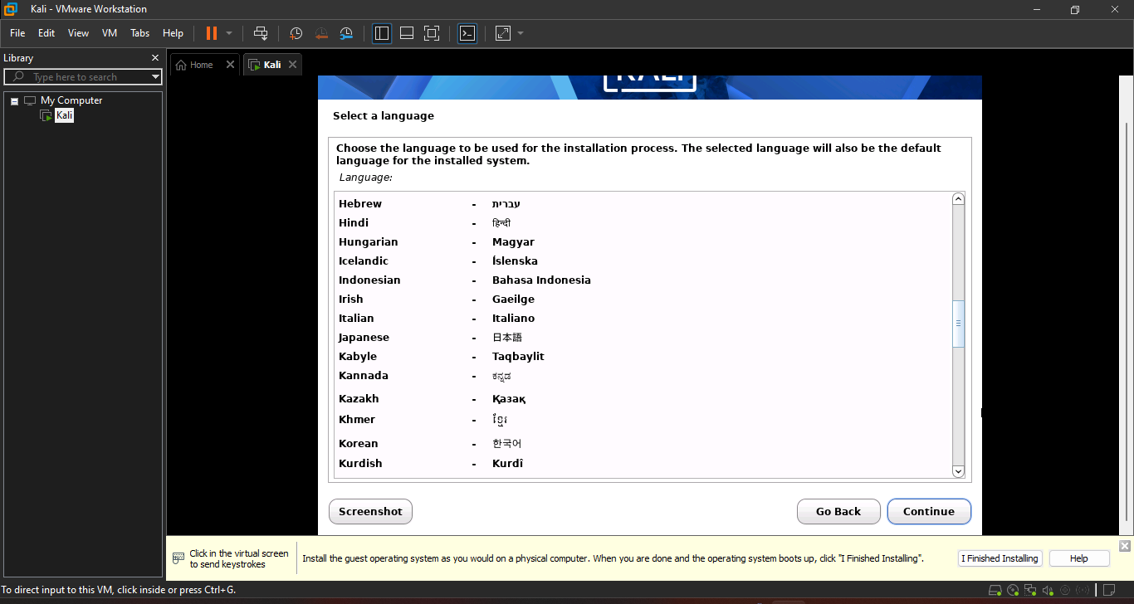
Now chose the location
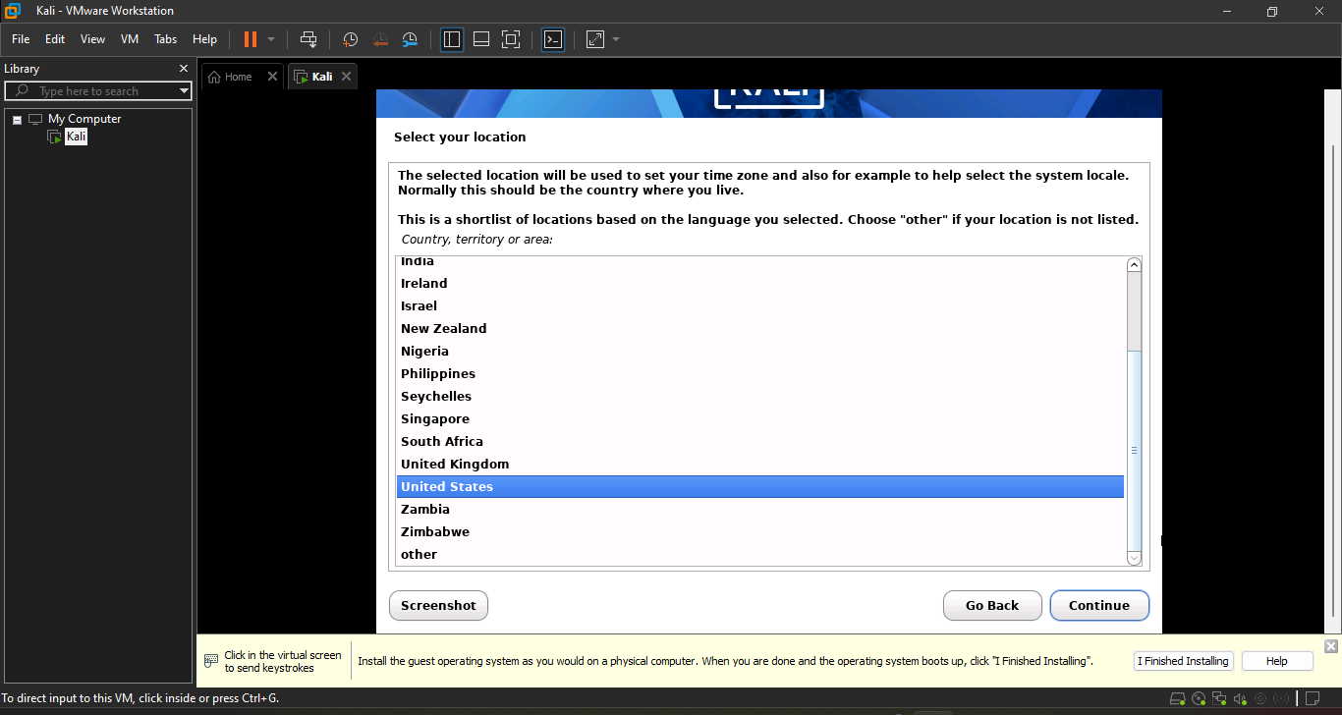
Then configure the keyboard:
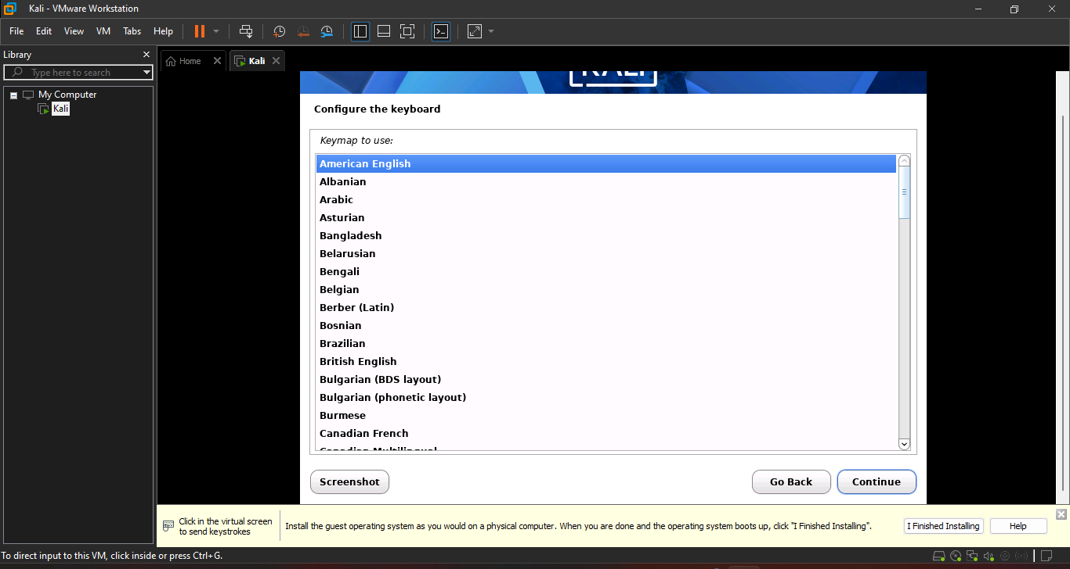
Select no for now
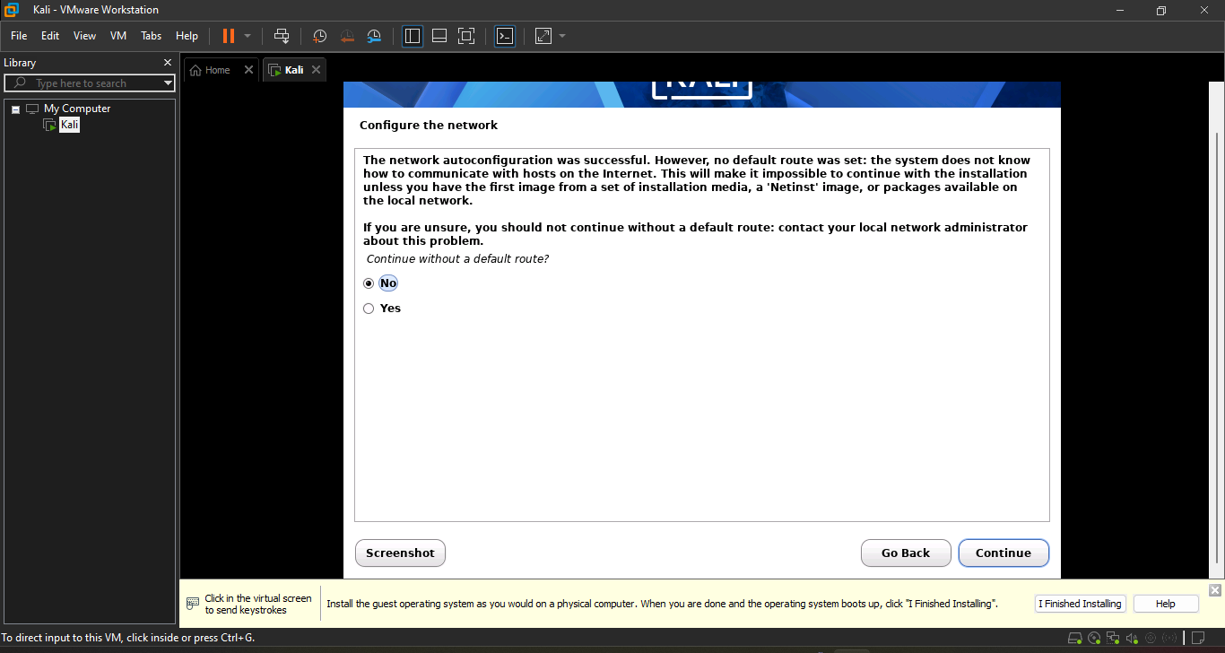
Choose the do not configure network:
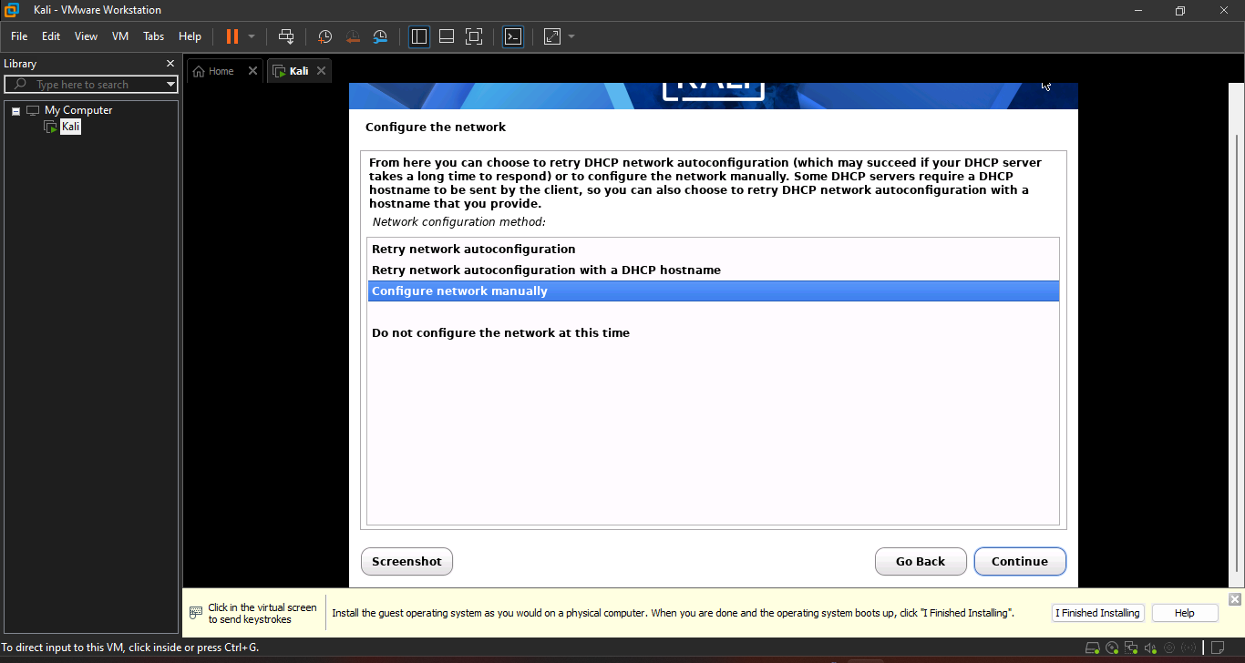
Give the host name to you virtual machine
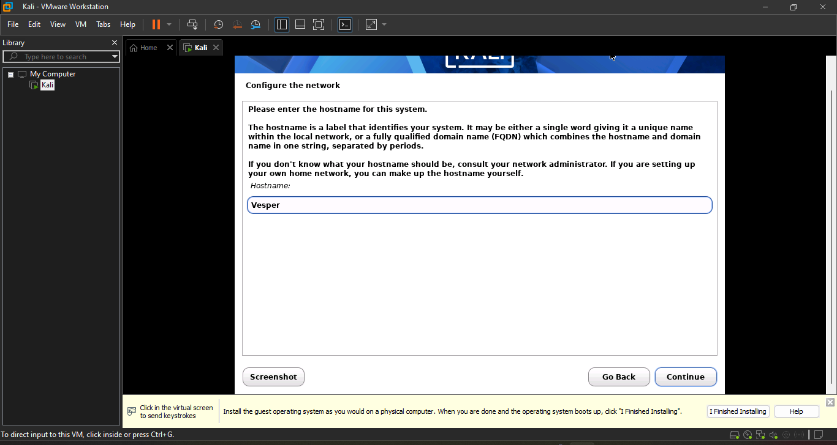
It will then ask for username and password after setting up the password and user name you will see this box select the time zone of your liking:
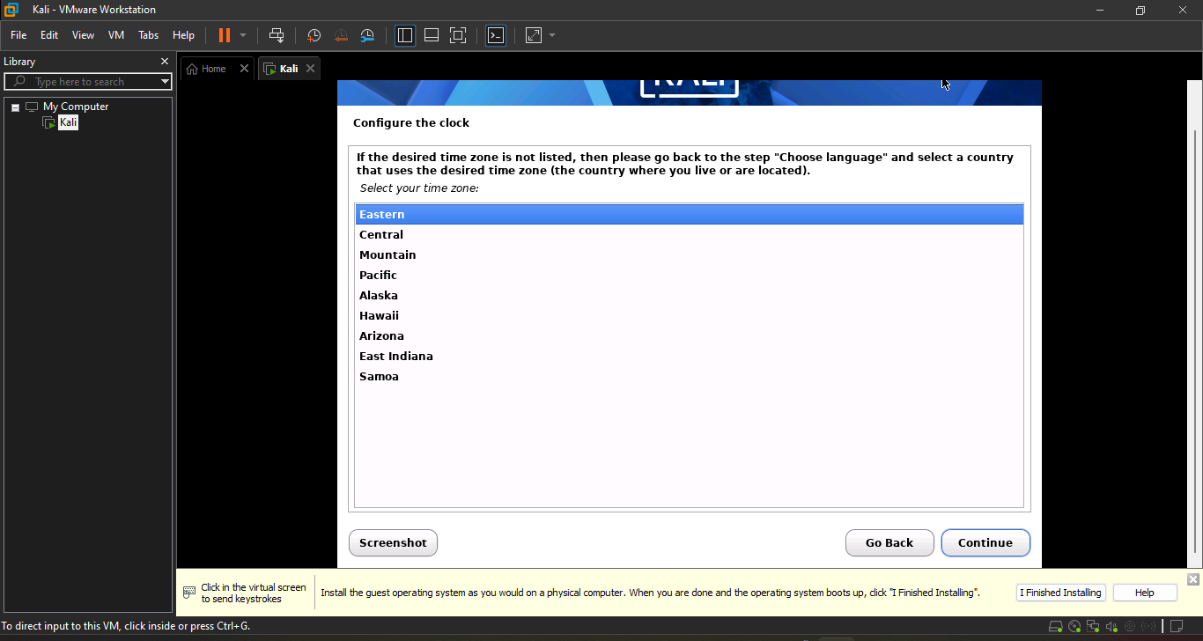
Select the entire disk option
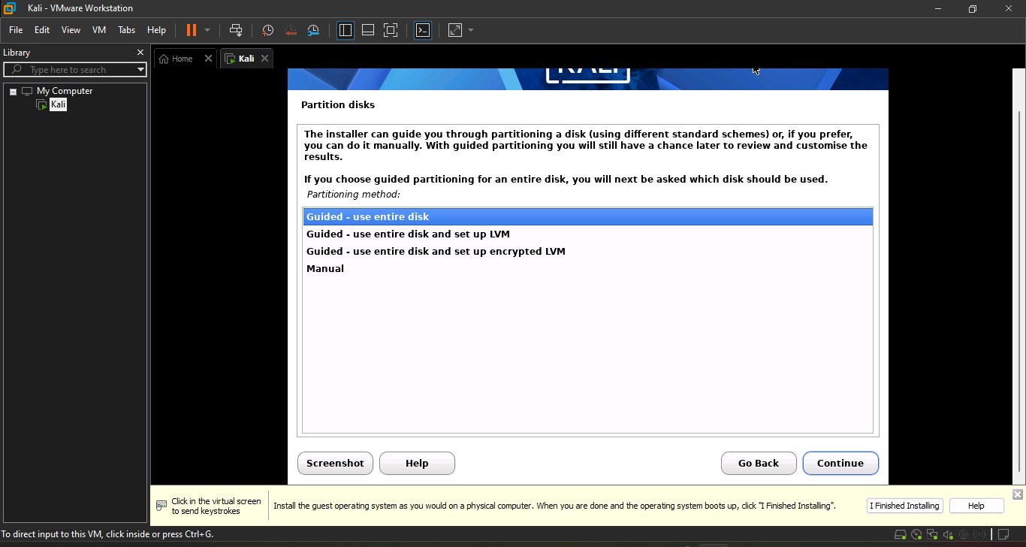
After clicking the continue select the all files in one partition folder
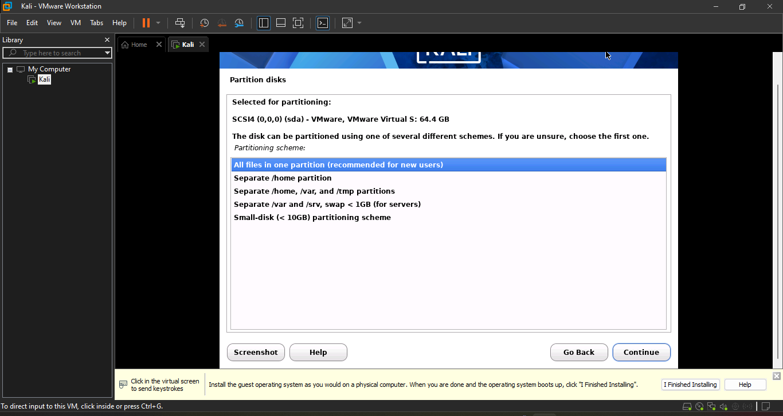
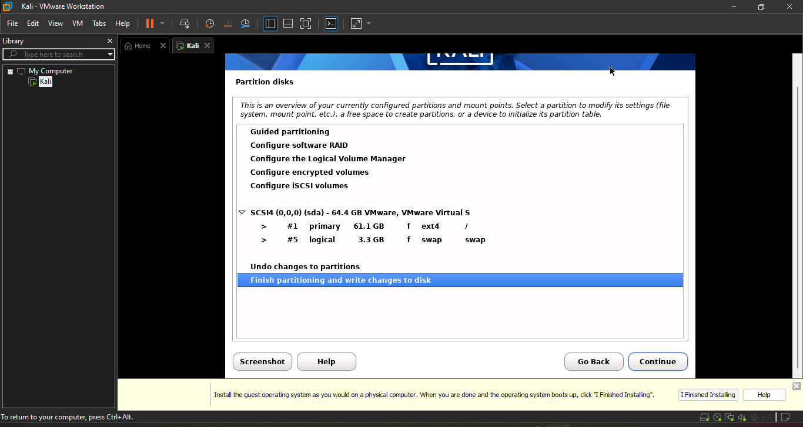
Chose the yes option and then click continue
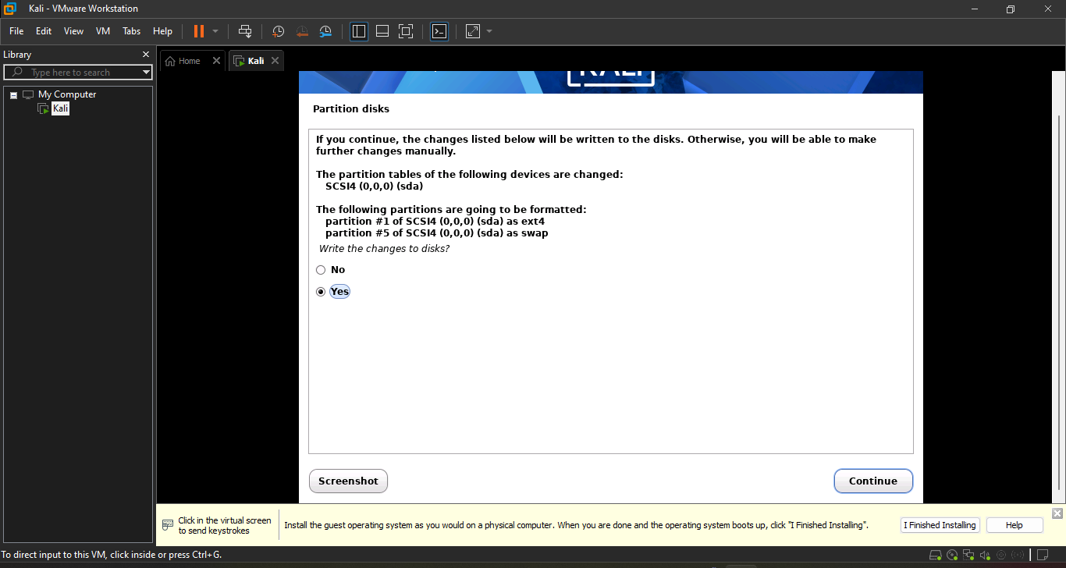

Click continue here keeping the setting as it is
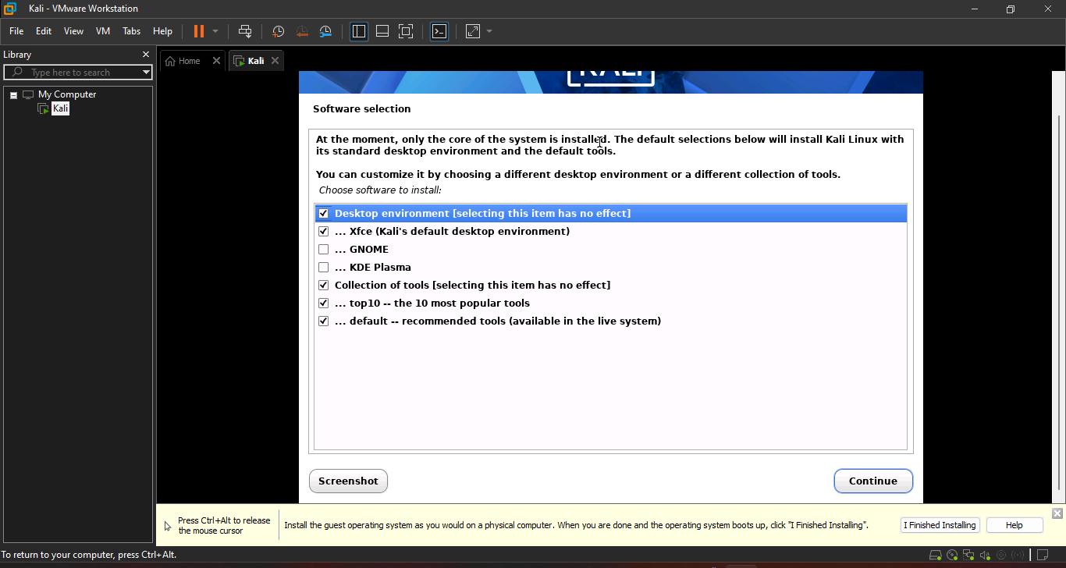
Your software installation will start then
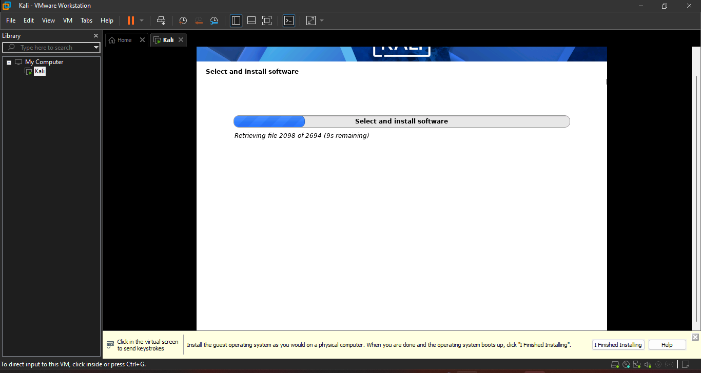
Choose yes here and click continue
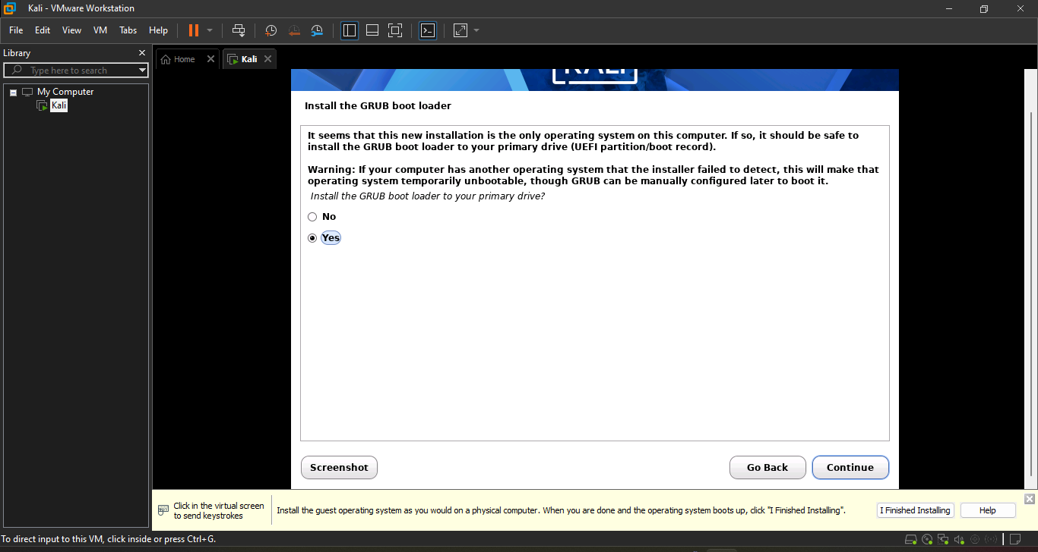
Now choose the following option
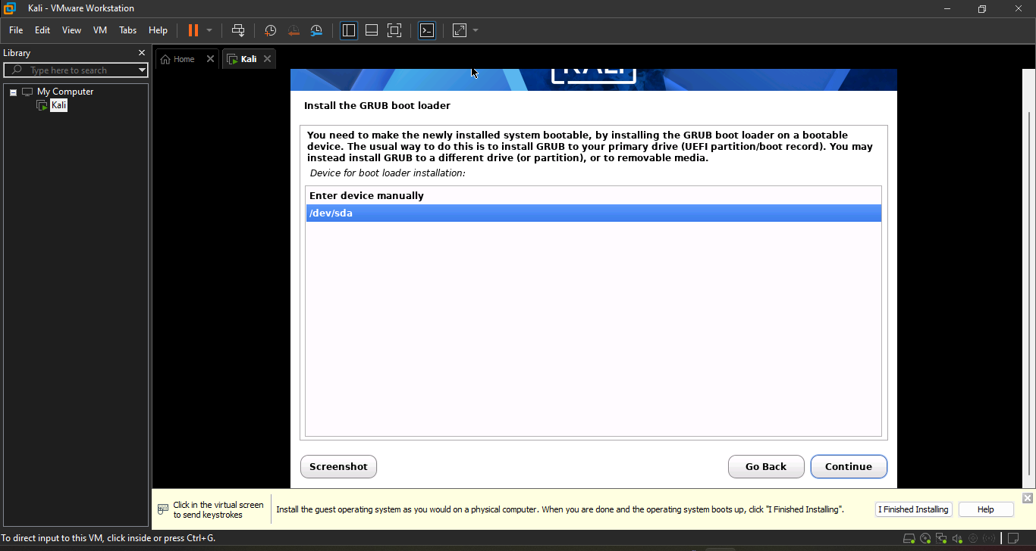
After completing installation you will see this screen here you have to choose the continue option to reboot your virtual machine
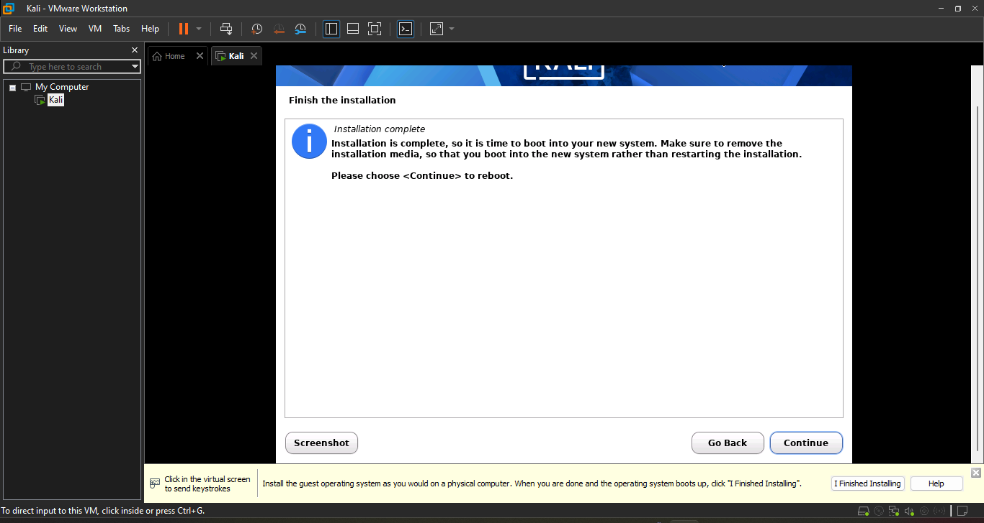
Enter your username and password then you are done
